24/7 Mental Health Urgent Care
Provides 24 hour/7 days/365 urgent care mental health screening and assessment services and medications to address the needs of those in crisis in a safe, efficient, trauma-informed, and least-restrictive setting.
Locations:
Riverside: 9990 County Farm Rd. Riverside, CA 92503 (951) 509-2499
Palm Springs: 2500 N Palm Canyon Dr, Suite # A4 Palm Springs, CA 92262 (442) 268-7000
Perris: 85 Ramona Expressway, Suites 1-3 Perris, CA 92571 951-349-4195 Main (ages 14+)

Urgent Mental Health care for children
Loma Linda Medical Center East Campus Advanced Urgent Care 25333 Barton Rd, Loma Linda, CA 92354 909-558-6641
HELPLine - 24 Hour Crisis/Suicide Intervention
The HELPline is a free, confidential Crisis/Suicide Intervention service. Operated by highly trained volunteers, the line is open 24-hours a day, seven days a week.
Phone: (951) 686-HELP (4357)

- Teen suicide Hotline via Boys Town: 800-448-3000 available 24/7 365 days
- Text HOME to 741741 to have a confidential text conversation with a trained crisis counselor from Crisis Text Line

National Suicide Prevention Lifeline
By calling 1-800-273-TALK (8255) you’ll be connected to a skilled, trained counselor at a crisis center in your area, anytime 24/7.
Phone: (800) 273-TALK (800-273-8255) Spanish line: (888) 628-9454 TTY: (800) 799-4TTY (4889)
Veterans Crisis Line
The Veterans Crisis Line is a Department of Veterans Affairs (VA) resource that connects Veterans in crisis or their families and friends with qualified, caring VA professionals. Confidential support is available 24 hours a day, 7 days a week. Phone: (800)-273-8255 Press 1
The Trevor Lifeline
National organization providing crisis and suicide prevention services to lesbian, gay, bisexual, transgender and questioning (LGBTQ) Youth 866-4-U-TREVOR (866-488-7386)

EMERGENCY PSYCHIATRIC HOSPITALS AFFILIATED WITH RUHSBH
Riverside University Health System Medical Center Emergency Treatment Services (ETS)
Provides psychiatric emergency services 24 hours a day, 7 days a week for all ages, which includes evaluation, crisis intervention, and referrals for psychiatric hospitalization, as needed for adults, children, and adolescents. Consumers may be referred to the Inpatient Treatment Facility (ITF) or other private hospitals.
9990 County Farm Road, Ste. 4
Riverside, CA 92503
Phone: (951) 358-4881
Se Habla Español

Telecare Riverside Crisis Stabilization Services
Provides psychiatric emergency assessment and crisis stabilization for up to 24 hours for all ages. Services include evaluations, crisis intervention and referral for psychiatric hospitalization. Telecare Riverside Crisis Stabilization Services operate 24 hours a day, 7 days a week. This facility is also a 5150 provider.
47-825 Oasis Street
Indio, CA 92201
Phone: (760) 863-8600 or (760) 863-8455
Se Habla Español

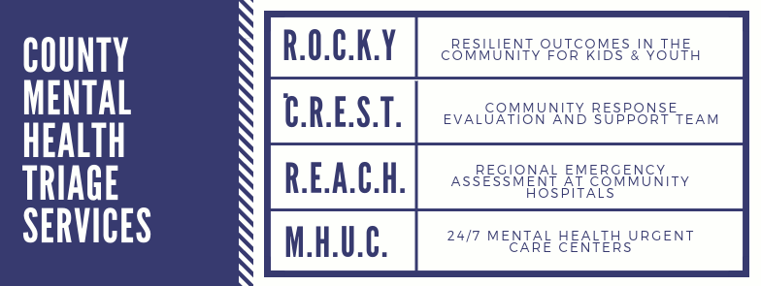

Resilient Outcomes in the Community for Kids & Youth (ROCKY)
The ROCKY program provides a range of crisis-related triage services to children aged 21 and under in need of assistance, or their parent, guardian, or caregiver.
- Diversion of persons in crisis to appropriate levels of care.
- Requiring stabilization and/or therapeutic or recovery focused services.
- Serving 21 and under
- Hours of operation: M-F 9:00 AM to 5:30 PM

The C.R.E.S.T. & R.E.A.C.H. Teams are part of the Crisis Support System of Care Program. These are field based teams consisting of Clinical Therapists, Behavioral Health Specialist and Peer Support Specialist working collaboratively with Law Enforcement & Emergency Department Personnel to decrease the need for inpatient hospitalizations as well as decreasing the amount of time that Law Enforcement & Emergency Department Personnel are dedicating to individuals in psychiatric crisis. The C.R.E.S.T. & R.E.A.C.H. Teams are able to work with individuals from all age groups.

Community Response Evaluation and Support Team (CREST)
CREST units work collaboratively with local Police and Sheriff Departments to decrease the need for inpatient hospitalizations as well as decreasing the amount of time that law enforcement personnel are dedicating to consumers in psychiatric crisis.
- Any age person that is experiencing a psychiatric crisis.
- Those with insurance and those without.
- Persons that are not already deemed needing to be placed on a 5150

Regional Emergency Assessment at Community Hospitals (REACH)

For more information: (951) 715-5040

24/7 Mental Health Urgent Care Centers (MHUC)
MHUC Riverside: 9980 County Farm Rd, Bldg. 2, Riverside 92503
Phone: (951) 509-2499
MHUC Perris: 85 Ramona Expressway, Ste. 1-3, Perris 92571
Phone: (951) 349-4195
MHUC Palm Springs: 2500 N. Palm Canyon Dr., Ste. A4, Palm Springs 92571
Phone: (442) 268-7000
- REACH units work collaboratively within community hospital emergency departments, to decrease the need for inpatient hospitalizations, as well as decreasing the amount of time that hospital medical staff is dedicating to patients in psychiatric crisis.
- Length of stay 24 hours.
- Screening, Assessment, Crisis Counseling, Peer Navigation and Support, Wellness Planning, Linkage to Ongoing Services, and Psychiatric Medications in a safe, efficient, Trauma-Informed, and least-restrictive setting.

