MENTAL HEALTH MONTH CALENDAR
MONDAY | TUESDAY | WEDNESDAY | THURSDAY | FRIDAY
2  Motivational Monday  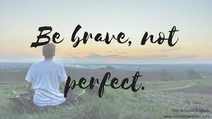  https://mentalhealthmatch.com/articles/anxiety/inspiring-mental-health-quotes  https://www.brainyquote.com/topics/motivational-quotes  https://www.keepinspiring.me/motivational-quotes/ | 3  Tuesday Tunes  Star Wars Day  Create your own energizing music playlist.  Share your playlist with a friend or colleague. | 4  Wellness Wednesday  Keep track of your water intake today.  See below to find out the best range for you.  https://www.mayoclinic.org/healthy-lifestyle/nutrition-and-healthy-eating/in-depth/water/art-20044256  There are many apps available to track your water intake as well. | 5  Thankful Thursday  Cinco de Mayo  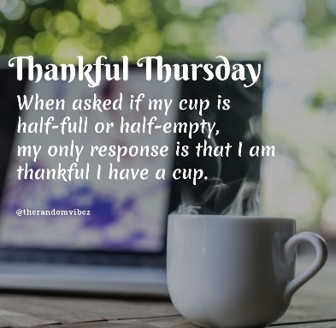 | 6  Fearless Friday  Courage: the ability to do something that frightens oneself.  Strength in the face of pain or grief.  What is one way you can use courage to be fearless this Friday?
9  Mindfulness Monday  Dr. Jon Kabat-Zinn has defined mindfulness meditation as “the awareness that arises from paying attention, on purpose, in the present moment and non-judgmentally”.  https://www.apa.org/topics/mindfulness/meditation  https://positivepsychology.com/what-is-mindfulness/  https://www.developgoodhabits.com/mindfulness-exercises/ | 10  Taco Tuesday  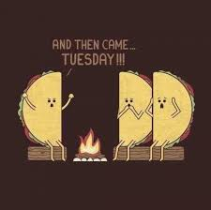 | 11  Wednesday Workout  National Eat What You Want Day  Youtube has an endless supply of workout videos and channels.  Share your favorite with a friend. | 12  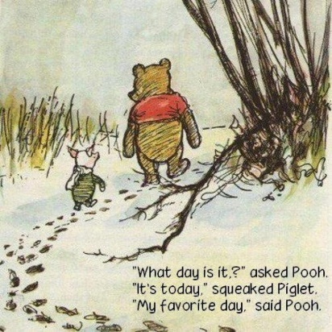 | 13  Feel good Friday  List three things that went well this week.  Pick one act of self-care you are going to work on this weekend.
16  Monday Music  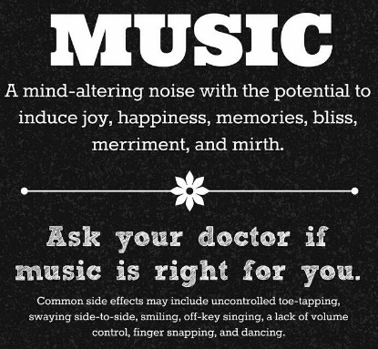 | 17  Tuesday Trivia  Test your mental health knowledge:  https://www.cdc.gov/mentalhealth/quiz/index.htm  Myths and facts:  https://www.mentalhealth.gov/basics/mental-health-myths-facts | 18  Wednesday Wonders  Awe: a feeling of respect mixed with fear or wonder  https://greatergood.berkeley.edu/article/item/eight_reasons_why_awe_makes_your_life_better | 19  Throwback Thursday  Looking back to one year ago, what memories pop up?  What did you learn in the past year? | 20  Foodie Friday  National Pizza Party Day  For pizza facts and fun ideas:  https://nationaltoday.com/national-pizza-party-day/
23  Mindfulness Monday  “Mindfulness shows us what is happening in our bodies, our emotions, our minds, and in the world. Through mindfulness, we avoid harming ourselves and others.”  – Thich Nhat Hanh  https://www.mindful.org/a-five-minute-breathing-meditation/  https://www.mindful.org/6-ways-practice-mindful-eating/ | 24  Travel Tuesday  World Schizophrenia Day  With the current travel restrictions, why not explore the local areas?  Be sure to check if they are currently open to the public.  https://vacationidea.com/california/day-trips-in-southern-california.html | 25  Wisdom Wednesday  What are the best words of wisdom you have received?  What words of wisdom make up part of your life philosophy? | 26  Thursday Thoughts  “Sometimes the people around you won’t understand your journey. They don’t need to, it’s not for them.”  – Joubert Botha | 27  Friday Fun  Would you rather have an extra finger or an extra toe?  Would you rather be able to control the weather or have the ability to talk to animals?  Would you rather always have to enter rooms by announcing your name or always have to do cartwheels out?

